**Title:**

HAPTIC GLOVE: VIBROTACTILE DELIVERY OF FACIAL EXPRESSIONS FOR PEOPLE WHO ARE BLIND

**Authors:**

Sreekar Krishna, Shantanu Bala, Troy McDaniel, Steven McGuire, and Sethuraman Panchanathan.

**Affiliation:**

Center for Cognitive Ubiquitous Computing (CUbiC), School of Computing, Informatics and Decision Systems Engineering (CIDSE), Arizona State University, 699 S. Mill Ave, Tempe, AZ 85281.

**Contact:**

[Sreekar.Krishna@asu.edu](mailto:Sreekar.Krishna@asu.edu), [Shantanu.Bala@asu.edu](mailto:Shantanu.Bala@asu.edu), [troy.mcdaniel@asu.edu](mailto:troy.mcdaniel@asu.edu), and [panch@asu.edu](mailto:panch@asu.edu). **Ph:** 480 727 3612. **Fax:** 480 965 1885

**Project Summary:**

**Introduction and Motivation:**

Nonverbal communication cues make up nearly 65% of all human interpersonal communication. Unless the communication is being carried out remotely (through telephone, instant messenger, twitter etc), people tend to enrich their communication through the use of head and body positions or movements, referred to as communicative postures or gestures, respectively. Some of the head based communicative cues include head nod, head shake, head tilt, eye gaze, and facial expressions, while, the body based communicative cues include hand movements, hand and leg crossing, overall body posture, appearance and proxemics (how people use and perceive the physical space around them to convey social, personal and intimate emotions). Most part of such head and body based cues are visual in nature and people who are blind cannot independently access this visual information, putting them at a disadvantage in daily personal and professional social encounters.

Of all the visual nonverbal cues, facial expressions play a very important role in everyday interpersonal communication. For example, during bilateral conversations, smile can convey agreement while a raised eyebrow can convey questioning. Very subtle movements on the facial features can convey rich and varied cues like desire, confusion, acceptance, anger, frustration, excitement, surprise, interest and even deception. Cultural artifacts impose variations on these visual displays of expressions, mannerisms and gestures which are very difficult to comprehend even with continuous visual feedback and social learning [Refer Social Learning Theory]. Recent studies on child development, especially children who are blind, have revealed the importance of nonverbal cues in the overall development of social skills. In a professional setting, people who are blind and visually impaired find these nonverbal cues to be very inaccessible. To compound these problems, sighted individuals are often unaware of their non-verbal cues and often do not (or cannot) make appropriate adjustments when communicating with people who are blind. Most individuals who are visually impaired find alternate modes for understanding some of these cues, such as, heightened auditory perception of sounds created by body movement. But facial movements are too subtle for any such auditory coding, unless they are co-conveyed through prosody. Any form of access to nonverbal cues can increase involvement of people who are visually impaired into the typical construct of human interpersonal communication.

We conducted an online survey of individuals who are blind or visually impaired to better understand their needs for support during social interactions [5]. Some of the important aspects of interactions that were identified include access to (1) information on the number and location of people standing in the front; (2) where individuals are directing their attention; (3) the identities of the people; (4) the appearance of people; (5) whether the physical appearance of a person has changed from a previous encounter; (6) the facial expressions of the person involved in a conversation; (7) the hand and body gestures of individuals involved in conversations; and (8) if the individual’s personal mannerisms might not fit the behavioral norms and expectations of the sighted people in an interaction. Among these, the personal mannerisms, facial expressions and identities of people ranked on the top three priorities. As discussed below, in the past, we have worked towards addressing the needs of personal mannerism [REF] and identities of people [REF]. This paper specifically discusses a novel interface that can deliver facial expressions through vibrotactile cueing.

**Social Interaction Assistant:**

At CUbiC, we have developed the Social Interaction Assistant [6]: a computer vision-based, wearable assistive device for individuals who are blind. The main components of this system include a pair of sunglasses with an embedded camera, on-body motion sensor, a computing element, and a vibrotactile belt that can convey elementary non-verbal communication cues [REF] while also delivering rehabilitative feedback towards reducing stereotypic body mannerisms [REF]. Adding to the capabilities of the Social Interaction Assistant, we are adding the Haptic Glove towards addressing the need to access facial expressions during interpersonal communicative conversations.

**Construction of the Haptic Glove:**

The haptic glove has 14 tactors (vibration motors – typically found inside cellular phone to cause vibration while ringing) mounted on the back of the fingers, one per phalange. The 14 motors correspond to the 14 phalanges (12 motors with 3 each on the index finger, middle finger, ring finger and the pinky with two on the thumb) on the human hand. A microcontroller is also integrated on the glove to allow control of the motor’s vibration (magnitude, duration and temporal rhythm) through the USB port of a PC.

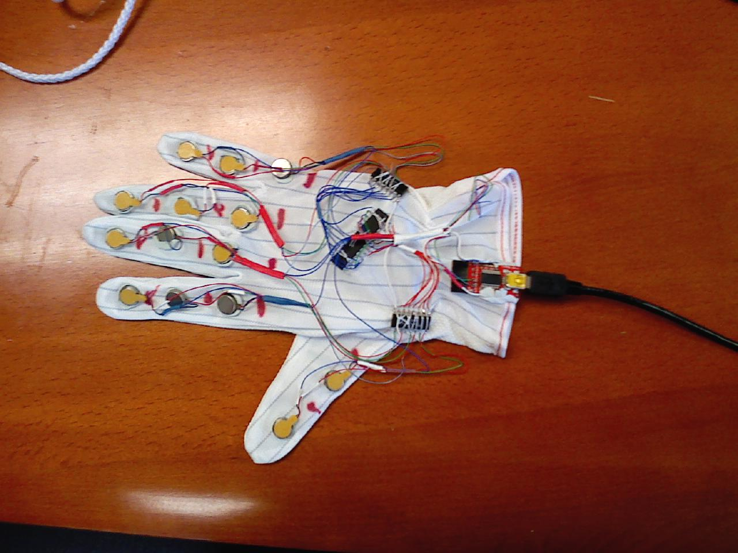

**Figure 1:** *Accessible Caption*: Haptic Glove: The figure shows an glove made out of streachable material with 14 vibrotactile motors on back of the hand with each motor corresponding to each phalange of the 5 digits. A microcontroller, two motor drivers and 1 USB controller (4 ICs) are also integrated on to the back of the glove with ultra thin flexible USB cable leaving the glove.

Figure 2 depicts the construction of each tactor on the belt. We used pancake cell phone vibratory motors which are installed on a perforated board along with an LED used as a visual indicator for debugging and testing. The perforated board itself was tied to a square piece of plastic canvas frame. The vibratory elements were joined with an elastic band that provides flexibility, ease of use and adaptability to different users. The motors themselves were connected using flexible multi stranded wires that allow for expansion and contraction of the belt around the waist. The control unit for the belt consisted of 7 opto-isolators controlled via 7 bits of a laptop PC’s parallel port. The actuation of the tactors is controlled through software that turns the bits of the parallel port high or low.

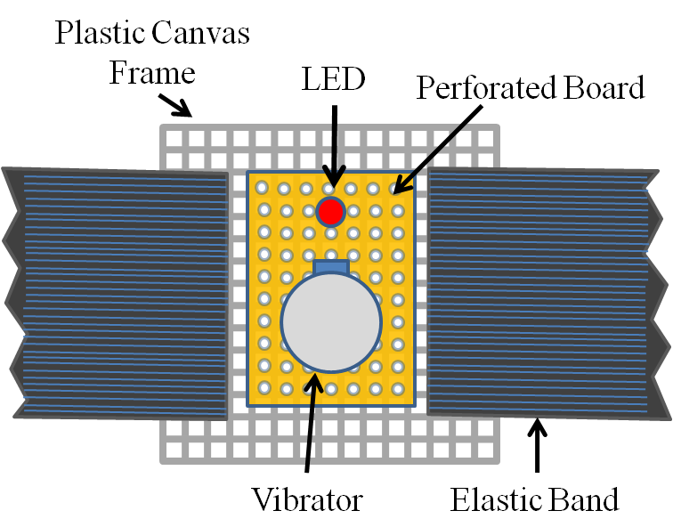

**Figure 2:** *Accessible Caption:* Individual Elements of the Haptic Belt: The figure shows the individual elements of the 7 vibrators on the belt. The complete description of these individual elements was provided in the paragraph above.

**Use Case Scenario:**

A person who is blind or visually impaired wears the glasses that has a camera discreetly built into the nose bridge (as described in [6]) and wears the haptic belt under their garments around the waist. The idea of the social interaction assistant is to communicate the location and distance of any person in front of the user using the position and duration of vibration on the belt. For now, only one person can be localized in front of the user; the one that is closest to the user. Figure 3 shows the device in action.

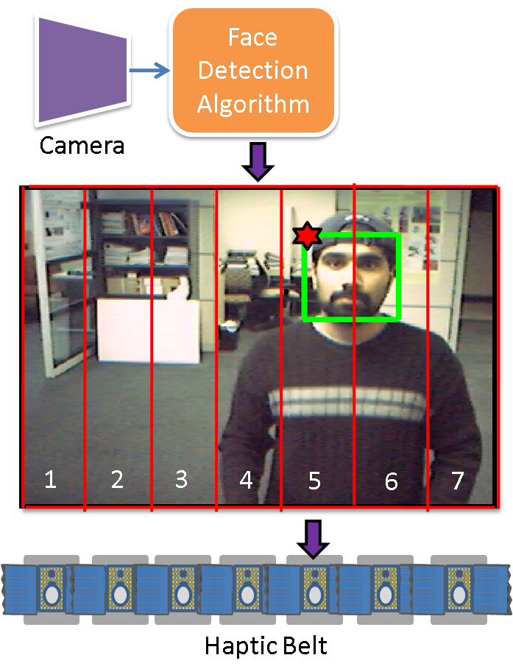

**Figure 3:** *Accessible Caption:* System architecture for haptic belt used as part of the Social Interaction Assistant: The figure depicts a camera as an input device followed by a Face Detection Algorithm module. The output of this module shows the image of a person with a green square box around the face. The green box represents the face detection output. This frame is divided into 7 regions corresponding to 7 vibrators on the haptic belt. The region where the top-left corner of the face box is located, decides which vibrator would indicate the location of person. The duration of vibration indicates the distance.

**References:**

1. S. Sacks, L. Kekelis, R. Gaylord-Ross, *The development of social skills by blind and visually impaired: exploratory studies and strategies*, AFB Press, New York, 1992.
2. M.L. Knapp and J.A. Hall, *Nonverbal communication in human interaction*, Wadsworth/Thomson Learning, 2005.
3. M.L. Knapp, *Nonverbal communication in human interaction*, Holt, Rinehart and Winston, 1978.
4. W.R. Wiener and G.D. Lawson, “Audition for the traveler who is visually impaired,” B.B. Blasch, W.R. Wiener, and R.L. Welsh (eds.), *Foundations of Orientation and Mobility*, Second Edition, AFB Press, New York, pp. 104-169, 1997.
5. S. Krishna, D. Colbry, J. Black, V. Balasubramanian and S. Panchanathan.   
   “A Systematic Requirements Analysis and Development of an Assistive Device to Enhance the Social Interaction of People Who are Blind or Visually Impaired.” Workshop on Computer Vision Applications for the Visually Impaired (CVAVI 08), A satellite workshop of European Conference on Computer Vision (ECCV 08), Marseille, France, Oct 18, 2008.
6. S. Krishna, G. Little, J. Black and S. Panchanathan, “A wearable face recognition system for individuals with visual impairments,” In Proceedings of the 7th International ACM SIGACCESS Conference on Computers and Accessibility, pp. 106-133, 2005.
7. P. Viola and M. Jones, “Rapid object detection using a boosted cascade of simple features,” In Proceedings of the IEEE Computer Society Conference on Computer Vision and Pattern Recognition, Vol. 1, pp. 511-518, 2001.